## Initial Setup

Download Android Studio: <http://developer.android.com/sdk/index.html>

(update IDE and SDK if prompted to do so after installation)

Download JDK 7: <http://www.oracle.com/technetwork/java/javase/downloads/jdk7-downloads-1880260.html> (Android Studio may also prompt you to install this and you can do it via that prompt if that is easier)

Next, in Android Studio, click the SDK manager button:

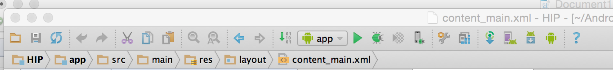

and ensure that Android 4.1 is installed (it’s probably okay if you don’t do this, because if you are missing this platform and you try to run the app inside Android Studio, it will prompt you to download missing platform versions such as 4.1)

## Emulators

If using HAXM to accelerate the emulator you will need to ensure you have an Intel CPU and that virtualization has been enabled in your BIOS (the HAXM installer will tell you if it detects virtualization or not, so you can always try installing it, but if it fails then you need to enable virtualization in the BIOS) more information can be found here <https://software.intel.com/en-us/android/articles/intel-hardware-accelerated-execution-manager>

HAXM can be installed directly from the SDK manager, which can be seen here:

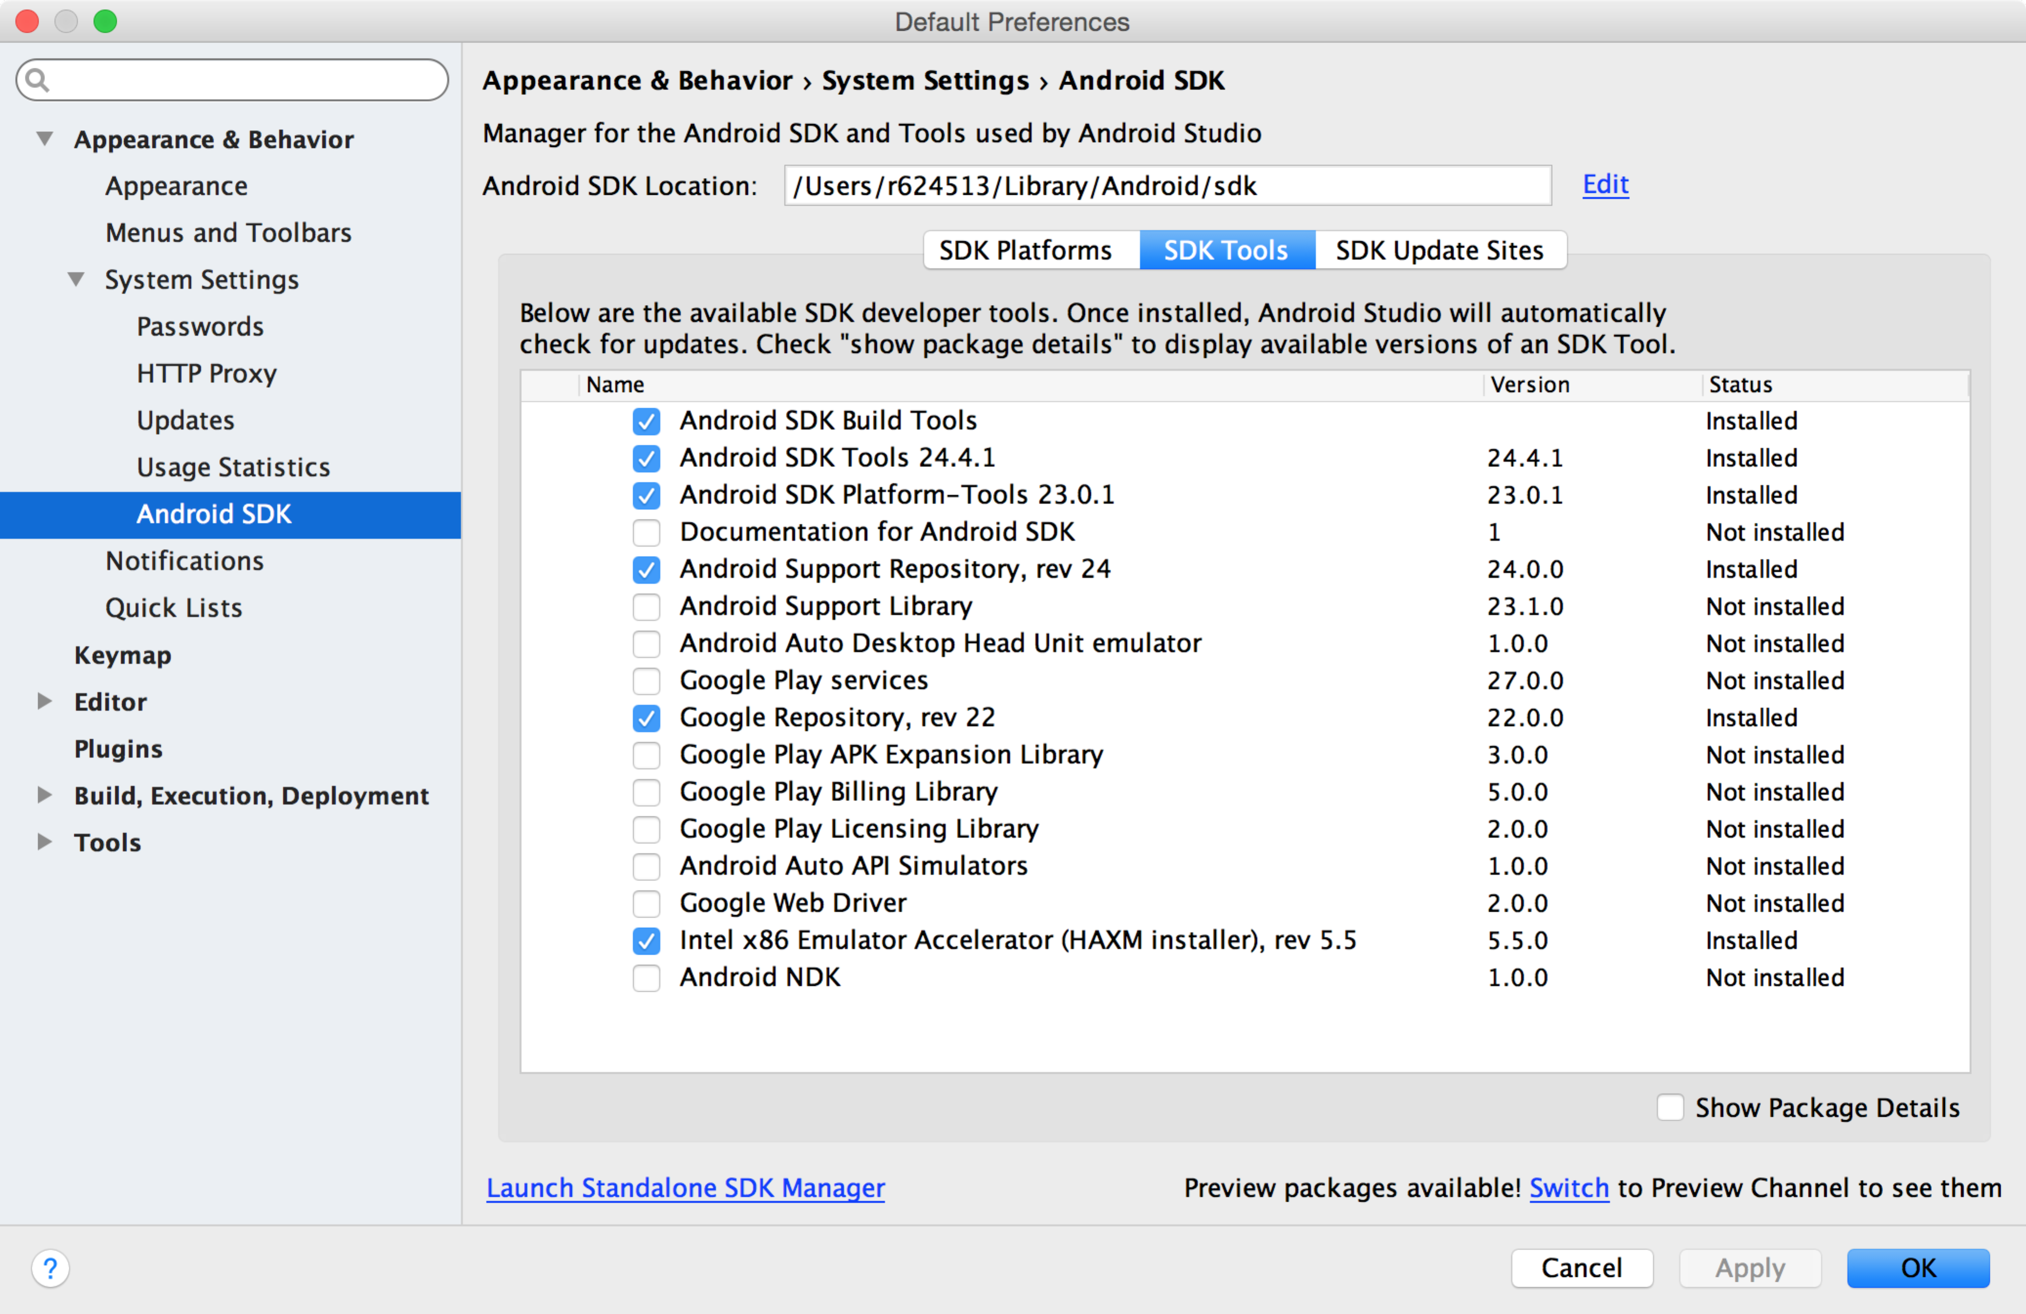

**If you do not have an Intel CPU or HAXM fails for some other reason I recommend using Genymotion.**

<https://www.genymotion.com/#!/download>

**This does require registering an account with them. Then follow their instructions (on the above web page) to install the Genymotion plugin for Android Studio.**

If using HAXM, Virtual devices (emulators) are managed under the AVD manager, which is the button after the SDK manager button



You can create new emulators in the AVD manager, using any system image that you have downloaded for any Android version (i.e. Android 4, 5 or 6 – however I believe at this time we will be focusing our efforts on 4.1, but that is still subject to change, and the app should be tested on 5 and 6 to ensure compatibility) – images that will work with HAXM are specified as Intel Atom images in the SDK manager. You will need to check the box for “Show Package Details” as can be seen in the screenshot below. Feel free to experiment with 64 bit images, though they may not work for you in which case you can stick with the default image.

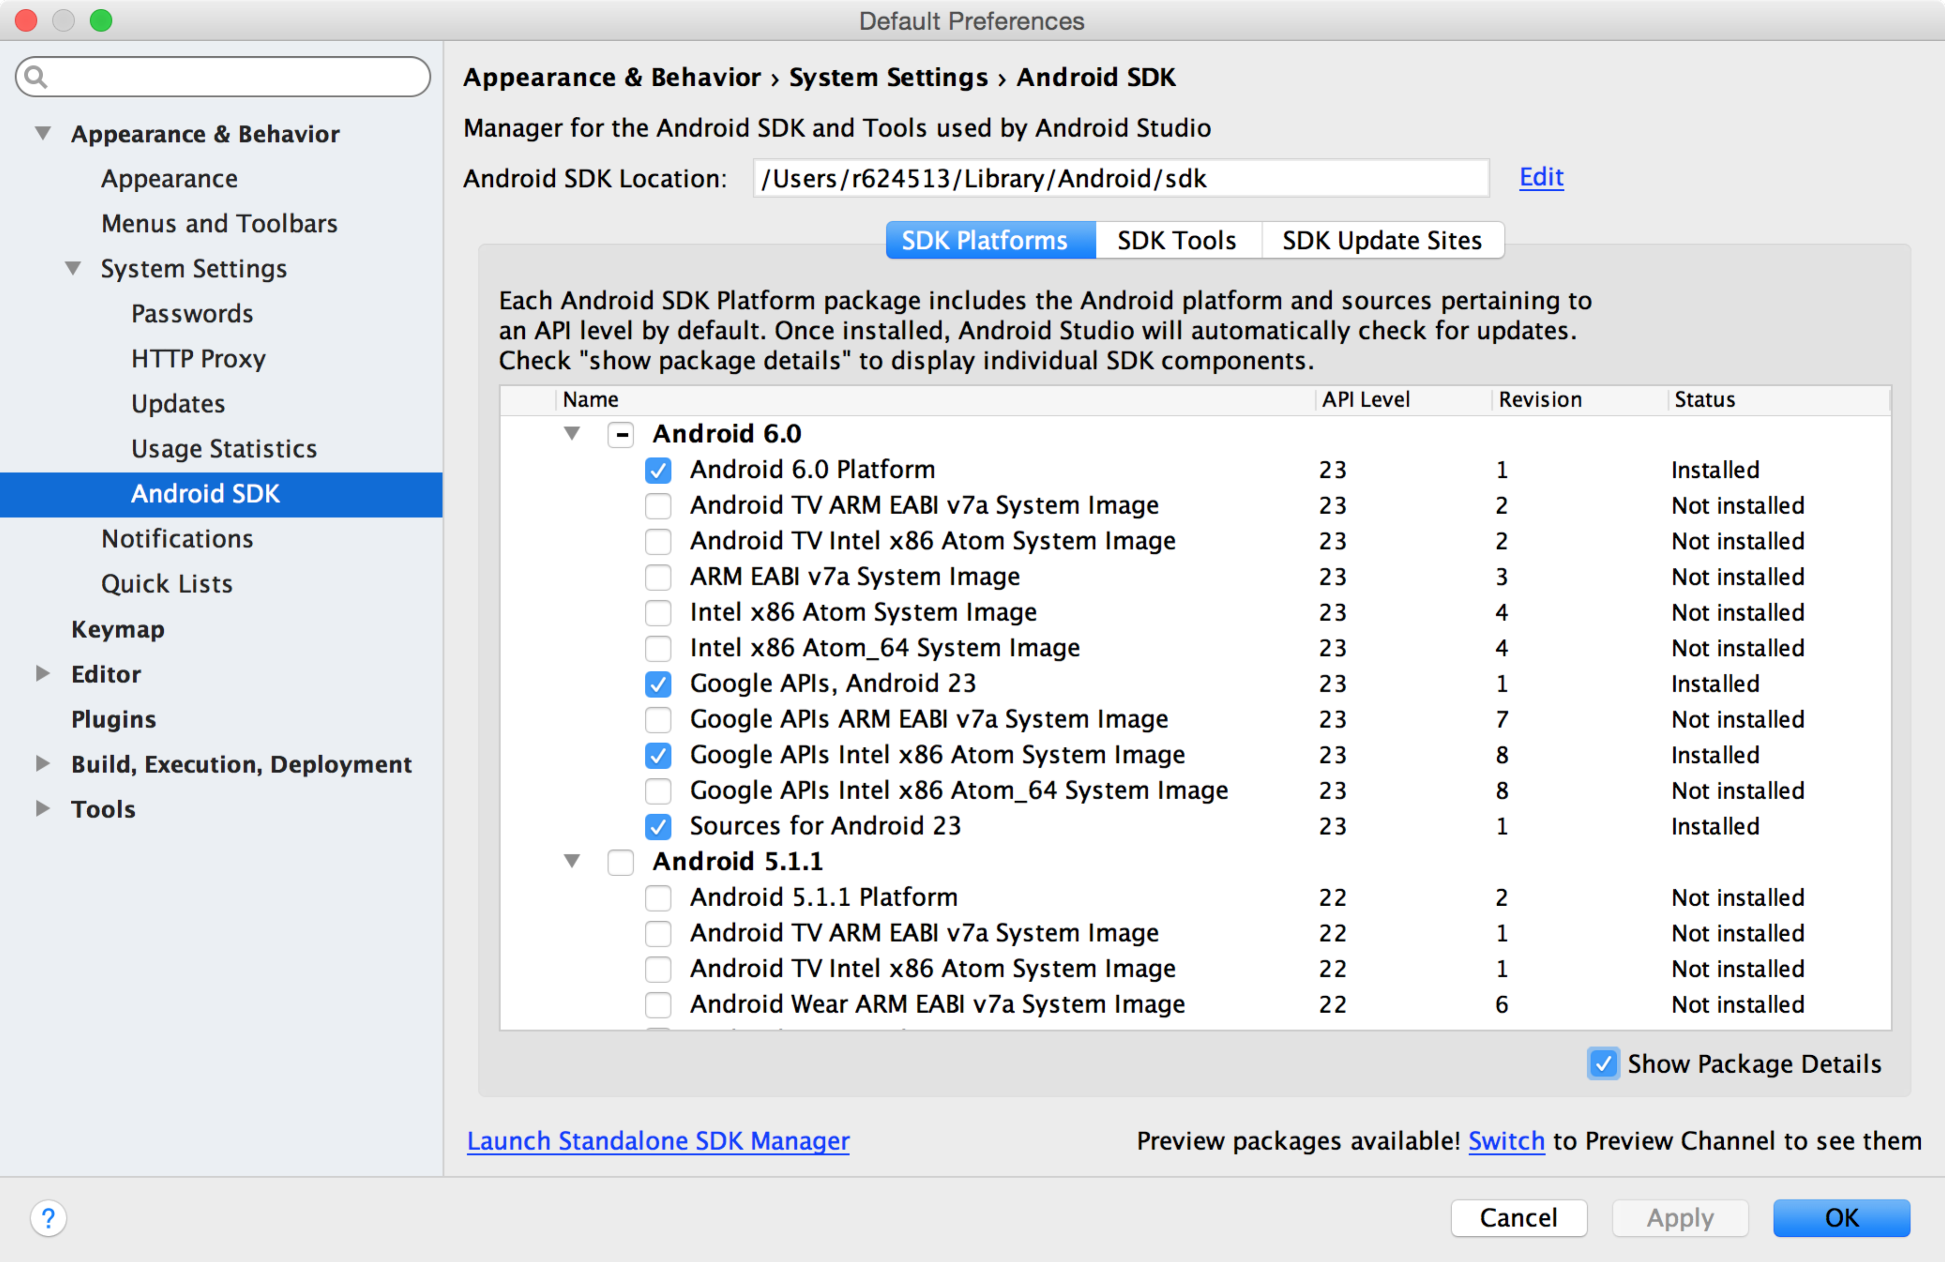

## Apps

There are three ways to get started with apps:

1. Clone a repository – MTI repo is: https://github.com/MedicalTeams/mti-android-app
2. Start a new project configured in any way you want.
3. Import a sample Android project that ships with the SDK. To do this, close any open projects and select “Import an Android code Sample” from the main splash screen.

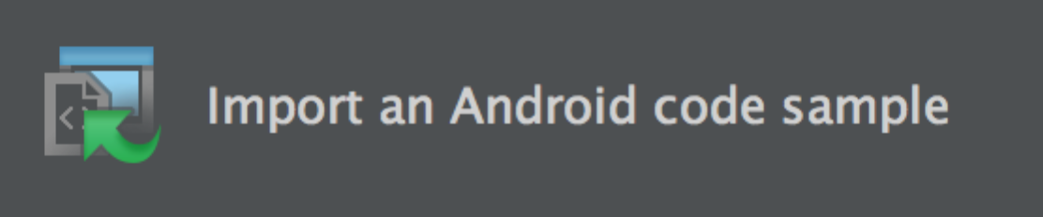

## Build System

Android Studio uses Gradle as its build system. Project dependencies (e.g. using Square’s networking library called [OkHttp](http://square.github.io/okhttp/) or installing automated testing tools such as [Espresso](https://google.github.io/android-testing-support-library/)) are managed with Gradle. For developers familiar with Java, this would be similar to bringing in a JAR file or using Maven. Often the project will need to be synchronized with Gradle before it will build and run, to force the IDE to do this, click on the “Sync Project With Gradle” button which is to the left of the SDK manager button and looks like this:

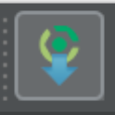

This will download any external dependencies and allow the app to run (this is important because generally these dependencies WILL NOT be in the MTI Github repository)

Other times a “Clean” is required and that option can be found under the Build menu (“Clean Project”).

Build output is found under Messages (Tab “0” under the tools windows also accessible under the “View” menu)

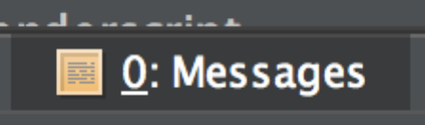

By monitoring this output and using Sync and Clean, you should be able to get the MTI app to run – if you are missing packages or dependencies those will show up in the Messages tab and sometimes you can download those missing dependencies directly from that tab.

Developing for Android is extremely easy once you get past the initial setup!